Directions for Making 100% recycled Wreath
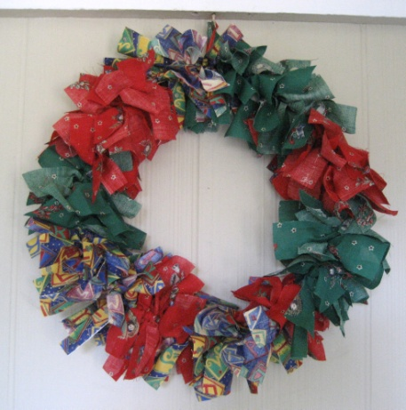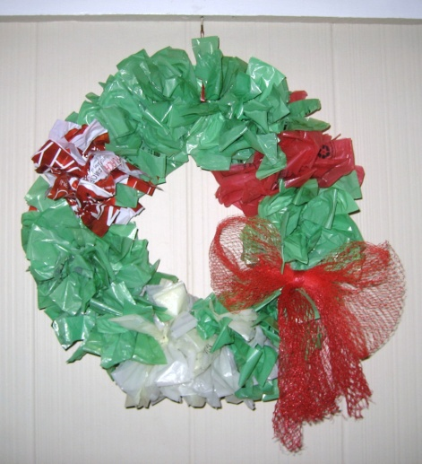

1.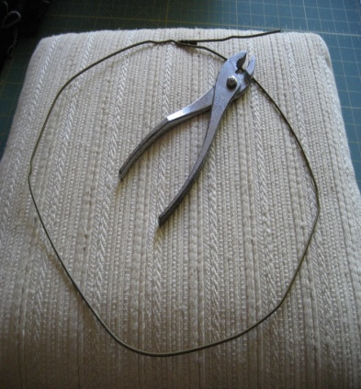2 & 3.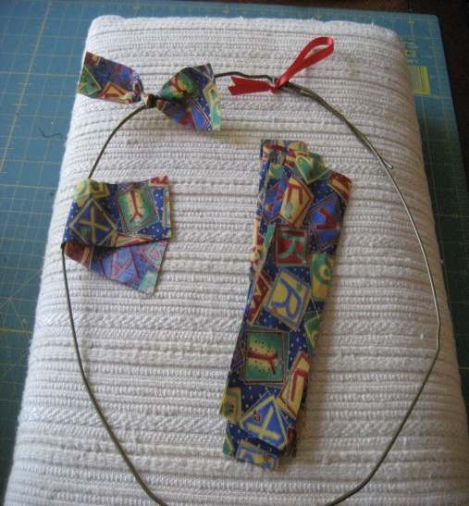4.

Materials: 1 yard of fabric total or 15 – 20 plastic bag sleeves your newspaper is protected by on rainy days
1 wire hanger & a short piece of ribbon
Directions: 1. Use pliers to help shape wire hanger into a circle.
2. Tie a short ribbon at the top for the wreath to hang by.
3. Cut fabric or plastic bags into 1-1/2" X 7" strips. The wreath pictured uses 1/3 yard each of
three different fabrics.
4. Tie strips around the hanger in any pattern you like. Just tie once, pulling ends securely.
5. The bow on the plastic wreath is made from a mesh bag that oranges came in and secured in
place with a grocery store tie band.
www.toteyourstuff.com 5/13

